# CJA-24 Authorization of Transcript Request

Step

**Click the Appointment List case number link on the Attorney Home page.**

Figure 1: Appointment List on Attorney Home Page

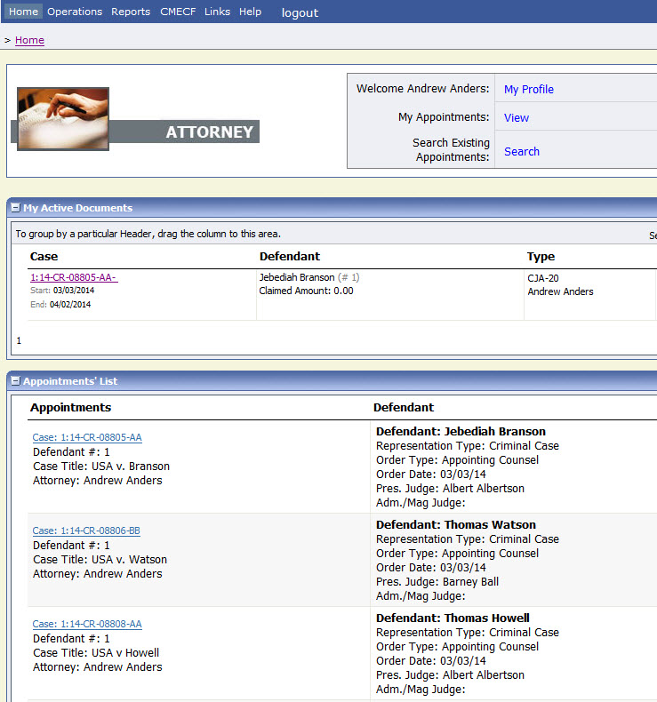

Step

**Select the AUTH-24 Create link on the left panel - on the Appointment Info screen.**

Figure 2: Create Auth-24 link on Appointment Info Screen

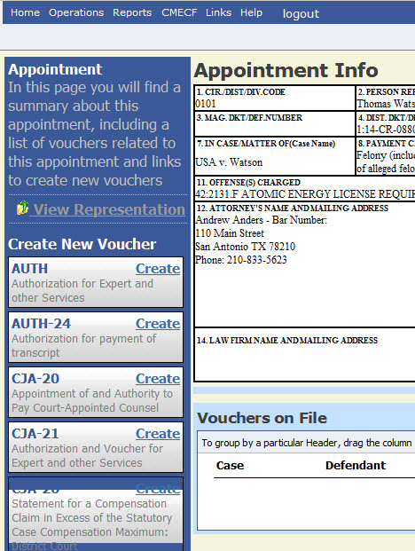

Step

**Enter the details of the transcript required on the Basic Info screen.**

Figure 3: Basic Info screen of the CJA24 Authorization.

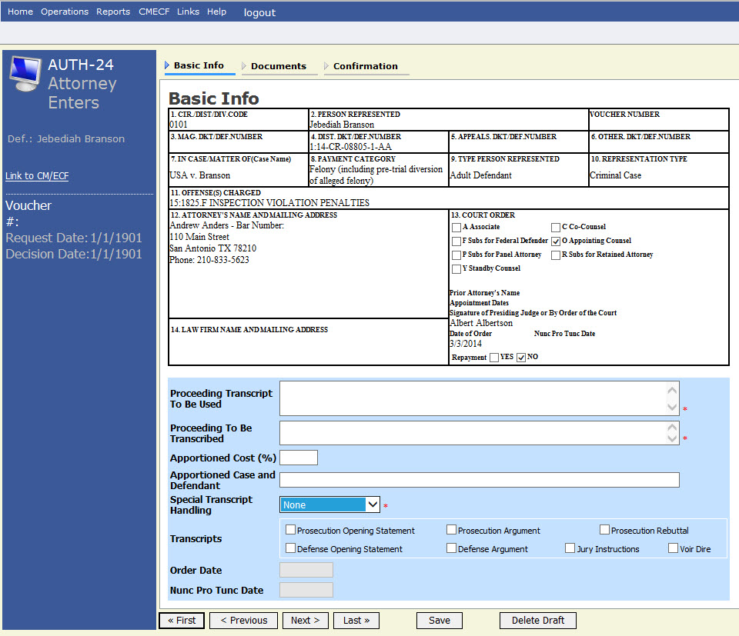

## Notes:

* Fill in the details for the transcript you are requesting. The required items are marked with a red asterisk.
* You may attach any relevant supporting documents on the **Documents** tab.

Figure 4: Special Transcript Handling drop-down list.

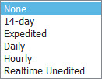

**Confirm and Submit the CJA24 Authorization.**

Step 4

Once you have selected the “I swear…” check box, the **Submit** button will become active. Click **Submit.** .

Figure 5: The Submit button on the Confirmation tab.

